|  |
| --- |
| ATZ Game Inc. |
| The Dragon Game |
| E:\My Logo\My Logo.png |
| Version 1.9  All work Copyright © 2015 by ATZ Games.  All rights reserved. |
| **Zexu Zhao (Adam)** |
|  |

|  |
| --- |
| January 30th 2015 |

Table of Contents

Version History 3

Detailed Game Description 4

I. Game Overview 4

II. Game Play Mechanics 4

*III.* Camera 4

IV. Controls 4

V. Saving and Loading 4

VI. Interface Sketch 4

VII. Game World 5

VIII. Levels 5

IX. Characters 5

X. Enemies 5

XI. Weapons 5

XII. Items 5

XIII. Abilities 5

XIV. Script 5

XV. Story Index 6

XVI. Future Features 6

# Version History

Version 1.1: Assignment#1 Create the project

Version 1.2: Finishing the test part and changing the Background

Version 1.3: Added the fourth slide but the link cannot lead me to that

Version 1.4: Finish all the slides and the connection between them

Version 1.5: Change a position of a slide

Version 1.6: Starting about the pictures. Added 3 images to Slide 1

Version 1.7: Finished adding 3 images to Slide 1

Version 1.8: Finished adding pictures for 3 slides

Current Version 1.9: Finished adding all the pictures for all the slides

# Detailed Game Description

## Game Overview

The goal of the game is to let people know how to make choices when they have some problems.

To win this game, the only thing you need to do is to make good choices in each step. There are 8 outcomes and only one of them will lead you to win.

## Game Play Mechanics

The game was uploaded onto the server and it can run on new version of browsers such as Google Chrome and Safari. Internet Explorer and Opera does not work.

## Camera

This is a 2D game and we can only see pictures from the screen.

## Controls

In this game, only the left button of the mouse can be used. Just click the choice you make, which will lead you to the next scene.

## Saving and Loading

There is no saving or loading in this game. You can only start over when you fail or win.

## Interface Sketch

Click the red link to go to the next scene.

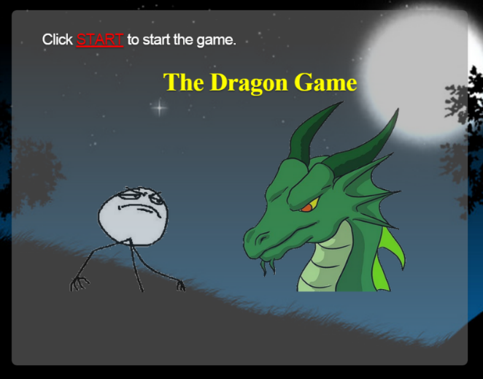

## Game World

This game happens at late night in caves in a forest.

## Levels

Level 1: The character sees two caves. One is dark and the other is bright.

Level 2: The character finds out that the situation in the caves and he needs to choose what to do.

Level 3: After making the choice, he needs to make another choice about how to do it.

## Characters

You, as an adventurer, explore two caves.

## Enemies

There is also a dragon, who will kill you if you make bad choices.

## Weapons

There is a sword in the dark cave that you can pick up if you can see.

## Items

There is a treasure chest in each of the cave. In the dark cave there is also a torch.

## Abilities

Character can only make choices. The behaviors are already set for the role.

## Script

game.js

impress.js

## Story Index

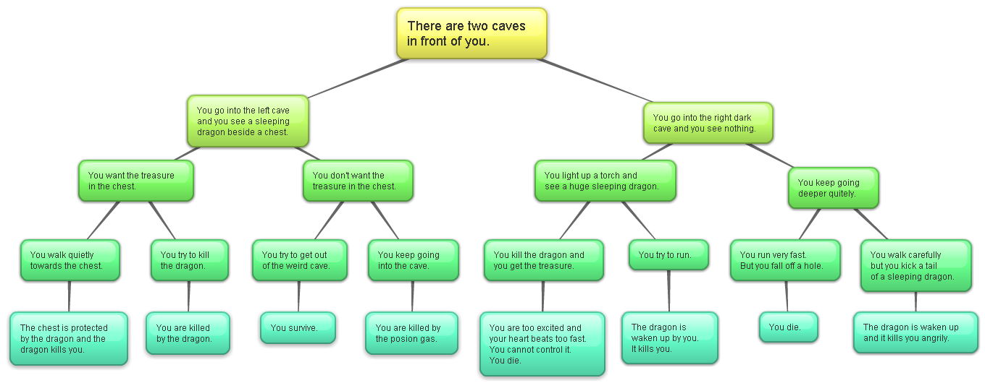

## Future Features

I will add some audio and moving cartoons.